AI Legal Intent Rewriter
Internal Planning Document
—
BTech CSE (AIML) – 8th Semester
Final Year Research Project – 4-Member Team
February 2026

1. Project Idea

1.1 The Problem
- Legal documents — tenancy agreements, employment contracts, software terms of service, insurance policies — are written in dense, archaic language inaccessible to non-experts.
- The overwhelming majority of people do not read these documents, and those who try are often left confused by nested clauses, domain-specific jargon, and ambiguous phrasing.
- This creates a genuine barrier to informed consent, leaving individuals exposed to unfavourable terms they never understood.

1.2 Our Proposed Solution
- A multi-stage NLP pipeline — the AI Legal Intent Rewriter — that ingests legal documents, breaks them into individual clauses, classifies each clause by type, extracts key entities, rewrites complex clauses into plain language, and flags potentially risky terms.
- Results are presented through a clean web-based dashboard where users upload documents and receive a structured, simplified breakdown.

1.3 Why It Matters
- Digital contracts are ubiquitous — people sign dozens of agreements each year, often on mobile devices, with no realistic opportunity to consult a solicitor.
- Our system acts as an automated first-pass interpreter that highlights what users need to pay attention to.

1.4 What Makes This Different
- Most existing tools offer surface-level summarisation or keyword extraction.
- Our pipeline goes further: it classifies the purpose of each clause, rewrites it in accessible language, and actively flags clauses that carry elevated risk (automatic renewal, liability waivers, penalty clauses).
- This layered approach provides genuine understanding, not just a shorter version of text users still cannot interpret.

2. Research Objectives
The following objectives define the concrete technical goals our team will achieve, arranged in pipeline order:
- Document Ingestion Module — Build a module that accepts PDF and plain-text legal documents, incorporates OCR (Tesseract) for scanned inputs, and produces clean text output for downstream processing.
- Clause Segmentation — Develop a segmentation module that splits legal documents into individual clauses with at least 85% boundary-detection accuracy.
- Clause Classification — Implement a transformer-based classifier to categorise clauses (liability, termination, payment, confidentiality, indemnification, etc.) with a target F1-score ≥ 0.80.
- Named Entity Recognition — Train or fine-tune an NER model to extract dates, monetary amounts, party names, rights, and obligations with entity-level F1-score ≥ 0.75.
- Intent Rewriting — Develop a seq2seq rewriting module that generates plain-language clause interpretations, evaluated via BLEU, ROUGE, and human readability scores.
- Risk-Flagging System — Design a rule-based system that identifies and highlights critical or disadvantageous clauses using keyword matching, regex patterns, and heuristic scoring.
- Web Dashboard — Build a responsive Next.js interface for document upload, clause-by-clause analysis viewing, and risk-flag exploration.
- Systematic Evaluation — Validate all pipeline components using quantitative metrics and qualitative user feedback.

3. Technology Stack
All tools and technologies listed below are free and open-source. No paid services or commercial APIs are used.
Category | Technology | Purpose
Programming Languages | Python 3.10+ | Core pipeline, model training, back-end API
 | JavaScript / TypeScript | Front-end web dashboard
ML / NLP Frameworks | TensorFlow 2.x | Model training and inference
 | Hugging Face Transformers | Pre-trained models (BERT, T5, BART), tokenisers, training utilities
 | spaCy 3.x | NER, sentence segmentation, text processing
Pre-trained Models | nlpaueb/legal-bert-base-uncased | Clause classification (domain-specific BERT)
 | bert-base-uncased / distilbert-base-uncased | Fallback classification and NER
 | google/flan-t5-small | Text simplification / rewriting
 | facebook/bart-base | Alternative seq2seq rewriting
 | en_core_web_trf / en_core_web_lg | spaCy NER base pipeline
OCR | Tesseract OCR (pytesseract) | Text extraction from scanned documents
PDF Processing | PyMuPDF (fitz) / pdfplumber | Text extraction from digital PDFs
Front-end | Next.js 14+ | React-based web application framework
 | Tailwind CSS | Utility-first CSS styling
 | TypeScript | Type-safe front-end development
Back-end API | FastAPI / Flask | REST API for pipeline orchestration
Database | PostgreSQL | Persistent storage for documents and results
 | Redis / MongoDB | Caching intermediate processing results
Annotation Tools | doccano / Label Studio | Manual NER and classification annotation
Training Infrastructure | Google Colab / Kaggle (free tier) | Cloud GPU access for model training
Containerisation | Docker (optional) | Reproducible development environment
Version Control | Git / GitHub | Source code management and collaboration

4. Methodology
This section details the end-to-end pipeline architecture with sufficient technical depth to serve as a working reference for the lead developer.

4.1 Pipeline Overview
The system follows an eight-stage sequential pipeline:
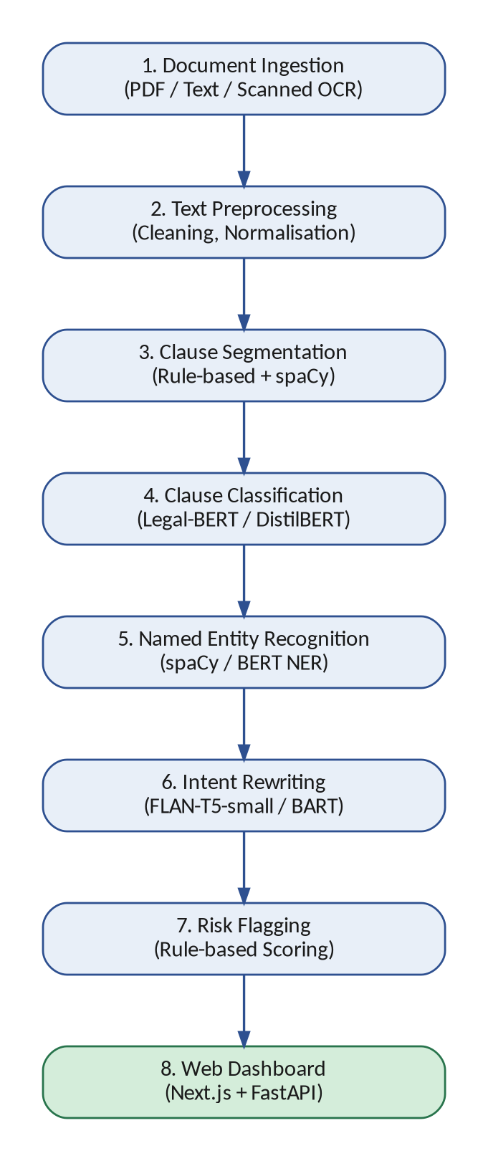
Figure 1: End-to-End Pipeline Architecture

4.2 Document Ingestion and Preprocessing
- Input formats: PDF (digital and scanned) and plain text.
- Digital PDFs: PyMuPDF (fitz) or pdfplumber for text extraction with structural metadata.
- Scanned PDFs: Tesseract OCR via pytesseract wrapper.
- Preprocessing steps: whitespace normalisation, header/footer/page-number removal, OCR artefact cleaning.
- Output: clean structured text ready for segmentation.
- Resource impact: lightweight; runs on any standard laptop.

4.3 Clause Segmentation
- Approach: hybrid of rule-based heuristics and NLP sentence detection.
- Rule-based layer: regex patterns targeting numbered sections, lettered sub-clauses, paragraph breaks, and indentation patterns.
- NLP layer: spaCy’s sentenciser as a foundation, augmented with custom legal-formatting rules.
- Fallback: sliding-window approach for irregularly structured documents, identifying boundaries based on content transitions.
- Target: ≥ 85% boundary-detection accuracy on manually annotated test documents.

4.4 Clause Classification
- Task: classify each clause into predefined categories (liability, termination, payment, confidentiality, indemnification, etc.).
- Primary model: nlpaueb/legal-bert-base-uncased with a linear classification head on the [CLS] token.
- Fallback model: distilbert-base-uncased (40% fewer parameters) or TF-IDF + SVM baseline.
Fine-tuning parameters:
- Optimiser: AdamW
- Learning rate: 2e-5 to 5e-5
- Batch size: 8–16 (with gradient accumulation if GPU memory limited)
- Epochs: 3–5 with early stopping on validation loss
- Sequence length: 512 tokens (post-segmentation clauses are typically within this limit; sliding-window with majority voting for longer clauses)
Handling class imbalance:
- Stratified sampling during train/validation splits
- Class-weighted cross-entropy loss
- Optional oversampling via random duplication or paraphrase augmentation
Evaluation: accuracy, macro-averaged precision, recall, and F1-score.

4.5 Named Entity Recognition (NER)
- Entity types: DATE, AMOUNT, PARTY, RIGHT, OBLIGATION, CONDITION
- Tag scheme: BIO (Beginning, Inside, Outside)
- Primary approach: adapt spaCy’s pre-trained pipeline (en_core_web_trf / en_core_web_lg) by adding custom entity types via the entity ruler and updating with annotated legal examples.
- Alternative: fine-tune Legal-BERT with a token classification head via Hugging Face (AdamW, LR 2e-5–5e-5, batch 8–16, 5–10 epochs).
- Annotation: 300–500 clauses annotated using doccano or Label Studio.
- Evaluation: entity-level F1-score (strict match), target ≥ 0.75.

4.6 Intent Rewriting Module
- Task: generate simplified, plain-language interpretations of legal clauses that preserve the original intent.
- Architecture: sequence-to-sequence (encoder–decoder).
- Primary model: google/flan-t5-small (~80M parameters) — instruction-tuned, compact, laptop-friendly.
- Alternative: facebook/bart-base if T5 presents compatibility issues.
- Conditioning method: prefix-based instruction tuning — inputs formatted as “Simplify this legal clause: [clause text]”.
- Fallback: template-based rewriting using clause category + extracted NER entities in predefined sentence structures.
Fine-tuning parameters (FLAN-T5-small):
- Optimiser: AdamW
- Learning rate: 1e-4 to 3e-4
- Batch size: 4–8
- Max input length: 512 tokens; max output length: 256 tokens
- Epochs: 5–10 with teacher forcing and label smoothing (0.1)
- Training infra: Google Colab / Kaggle free-tier GPUs if local resources insufficient
Evaluation: BLEU, ROUGE-L (automated); human readability scoring on a 1–5 Likert scale (clarity, completeness, faithfulness) by 3–5 evaluators.

4.7 Risk-Flagging Module
This module uses a deterministic, rule-based approach for transparency and interpretability:
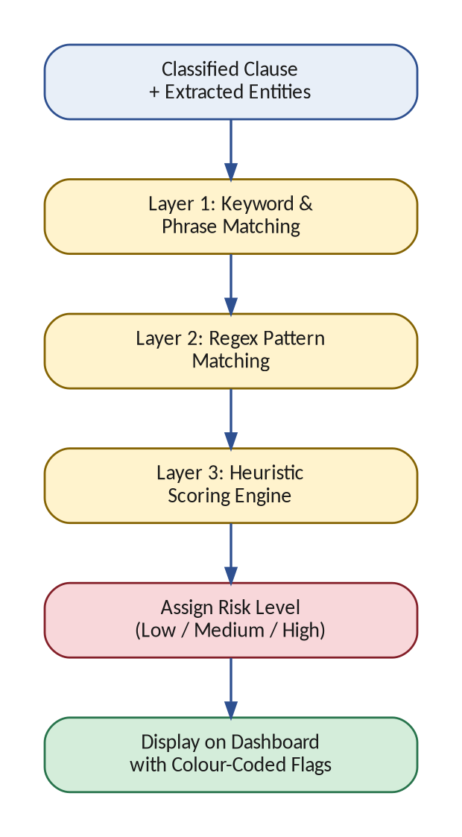
Figure 2: Risk-Flagging Logic Flow
- Layer 1 — Keyword matching: curated dictionary of risk terms (e.g., “irrevocable”, “sole discretion”, “automatic renewal”, “waive any right”, “liquidated damages”, “non-refundable”).
- Layer 2 — Regex patterns: structural risk indicators such as unusually short notice periods, uncapped liability, one-sided termination rights.
- Layer 3 — Heuristic scoring: combines keyword density, clause category (from classifier), and entity values (from NER) to assign risk levels (low, medium, high).
- Example: a termination clause with notice < 7 days + “without cause” = high risk.
- Iteration: keyword dictionary and patterns expanded iteratively based on testing against real documents.

4.8 Model Selection Decision Framework
The team will decide between fine-tuning and lighter alternatives during development. The following decision flow guides the choice:
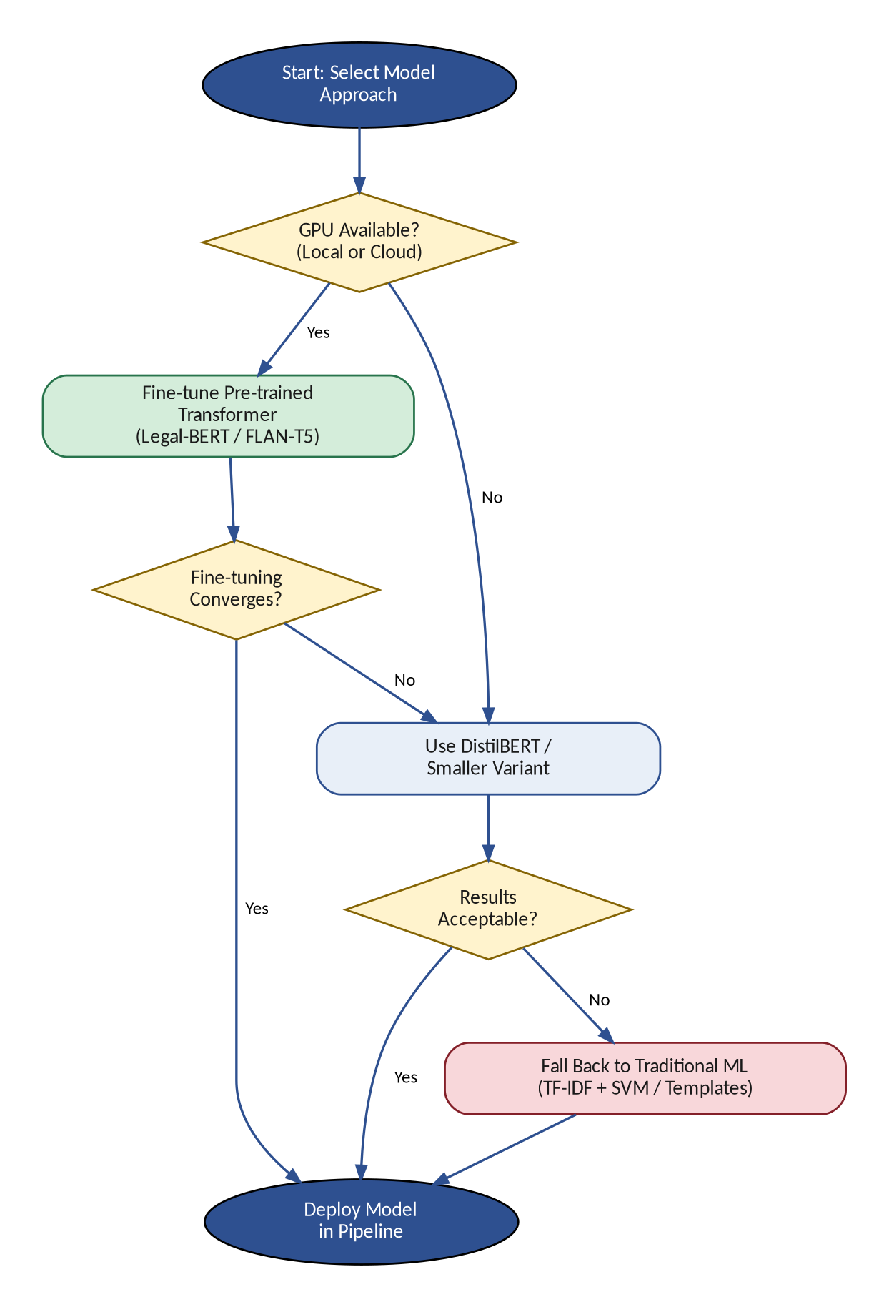
Figure 3: Model Selection Decision Framework
- Path A — Fine-tuning: preferred when GPU access (local or Colab/Kaggle) is available and models converge within acceptable time.
- Path B — Smaller variants: DistilBERT for classification/NER; FLAN-T5-small remains compact for rewriting.
- Path C — Traditional ML: TF-IDF + SVM/logistic regression for classification; template-based rewriting. Used only if neural approaches prove infeasible.

4.9 Web-Based Dashboard
- Front-end: Next.js + TypeScript + Tailwind CSS.
- Features: drag-and-drop upload (with file type validation), processing status indicator, clause-by-clause results view.
- Results display: colour-coded risk flags, clause category labels, extracted entities, simplified rewrite alongside original text (side-by-side or accordion layout).
- Back-end: Python (FastAPI or Flask) exposing REST endpoints for upload, processing status, and results retrieval.
- Storage: PostgreSQL for documents and clause data; Redis/MongoDB for caching.

4.10 Evaluation Strategy
Component-level metrics:
- Classification & NER: accuracy, precision, recall, F1-score on held-out test sets.
- Rewriting: BLEU, ROUGE-L (automated) + human readability scoring (1–5 Likert).
- Risk flagging: precision and recall against manually annotated risky clauses.
System-level evaluation:
- End-to-end testing with real legal documents across multiple types.
- Small user study: participants interact with the dashboard and provide structured feedback on usability, clarity, and trust.

5. Implementation Plan
Development is structured across five phases over 16–18 weeks:
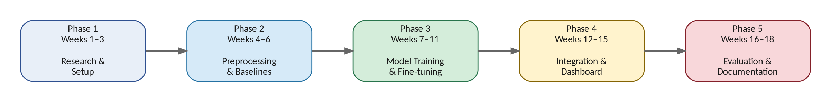
Figure 4: Phase Timeline Overview
Phase | Duration | Key Tasks & Deliverables | Team Responsibility
Phase 1 | Weeks 1–3 | • Literature review (legal NLP, text simplification, clause classification)  • Dataset identification and collection  • Environment setup (Python, TensorFlow, HF, spaCy, Tesseract, PostgreSQL)  • Initial data exploration and quality assessment  Deliverables: Annotated bibliography, raw datasets, configured environments | Lead dev: environment setup, model research, code scaffolding  Team: literature review, dataset sourcing, annotation tool setup
Phase 2 | Weeks 4–6 | • Data preprocessing and cleaning pipeline  • Clause segmentation module development  • Baseline model experiments (TF-IDF + SVM)  • First fine-tuning runs and benchmark establishment  Deliverables: Working segmentation module, preprocessed data, baseline benchmarks | Lead dev: segmentation module, baseline experiments  Team: data preprocessing, annotation, front-end scaffolding
Phase 3 | Weeks 7–11 | • Classification model training (Legal-BERT / DistilBERT)  • NER model adaptation (spaCy / BERT token classifier)  • Rewriting module fine-tuning (FLAN-T5-small)  • Hyperparameter tuning, data augmentation, error analysis  Deliverables: Trained models, training logs, performance reports | Lead dev: all model training, fine-tuning, experimentation  Team: continued annotation, data augmentation, front-end components
Phase 4 | Weeks 12–15 | • Pipeline integration (all modules end-to-end)  • Risk-flagging module implementation  • Full front-end + back-end integration  • End-to-end testing and optimisation  Deliverables: Integrated pipeline, working dashboard, test results | Lead dev: pipeline integration, API, risk-flagging logic  Team: front-end completion, testing, user feedback collection
Phase 5 | Weeks 16–18 | • Systematic evaluation (metrics + user study)  • Final bug fixes and polish  • Documentation (technical report, user guide, code docs)  • Final presentation preparation  Deliverables: Evaluation report, documentation, presentation, deployable system | Lead dev: final optimisations, code documentation  Team: evaluation execution, documentation, presentation design

6. Expected Outcomes

6.1 Tangible Deliverables
- Working end-to-end NLP pipeline that ingests legal documents and produces clause-level analysis (classification, entity extraction, simplified rewrites, risk flags).
- Trained / fine-tuned models for clause classification, NER, and text simplification, with documented performance benchmarks.
- Responsive web dashboard providing an intuitive interface for document upload, analysis viewing, and risk-flag exploration.
- Comprehensive project documentation: technical report, codebase documentation, and user guide.
- Evaluation report presenting quantitative metrics and qualitative user feedback.

6.2 Definition of Success
- A user with no legal training can upload a rental agreement, employment contract, or ToS and receive a clear, clause-by-clause explanation with risky terms prominently highlighted.
- The system does not replace legal advice but empowers users to ask better questions and make more informed decisions.

6.3 Broader Impact
- Democratises access to legal comprehension for individuals and small businesses who cannot afford routine legal consultation.
- Contributes to more equitable participation in contractual relationships.

6.4 Future Scope
- Multilingual support: starting with Hindi and other widely spoken Indian languages.
- Mobile application: on-the-go document analysis.
- Domain adaptation: medical consent forms, financial disclosures, government regulatory documents.
- Feedback loop: user corrections improve model performance over time.

7. Key Risks and Mitigations
Risk | Mitigation
Limited GPU access for model training | Use free-tier cloud GPUs (Google Colab, Kaggle). Prefer smaller models (DistilBERT, FLAN-T5-small). Gradient accumulation for larger effective batch sizes. Fall back to non-neural baselines if needed.
Legal text complexity and variability | Focus on common document types during development (rental, employment, ToS). Use domain-specific pre-trained models (Legal-BERT) for stronger out-of-the-box performance.
Class imbalance in training datasets | Stratified sampling, class-weighted loss functions, and data augmentation (paraphrase generation, synonym replacement) to balance training distribution.
Insufficient annotated training data | Supplement public datasets with team-annotated examples. Use active learning to prioritise annotation of the most informative samples. Start with a smaller label set and expand incrementally.
Time constraints (16–18 week timeline) | Strict phase discipline with weekly check-ins. Define a minimum viable product (MVP) scope and treat additional features as stretch goals.
Integration complexity across pipeline stages | Define clear input/output contracts between modules from the outset. Standardised JSON data formats for inter-module communication. Begin integration testing early in Phase 4.

8. References
- Devlin, J., Chang, M.-W., Lee, K. and Toutanova, K. (2019) ‘BERT: Pre-training of Deep Bidirectional Transformers for Language Understanding’, Proceedings of NAACL-HLT 2019, pp. 4171–4186.
- Chalkidis, I., Fergadiotis, M., Malakasiotis, P., Aletras, N. and Androutsopoulos, I. (2020) ‘LEGAL-BERT: The Muppets Straight Out of Law School’, Findings of EMNLP 2020, pp. 2898–2904.
- Raffel, C., Shazeer, N., Roberts, A. et al. (2020) ‘Exploring the Limits of Transfer Learning with a Unified Text-to-Text Transformer’, Journal of Machine Learning Research, 21(140), pp. 1–67.
- Chung, H.W., Hou, L., Longpre, S. et al. (2022) ‘Scaling Instruction-Finetuned Language Models’, arXiv preprint arXiv:2210.11416.
- Lewis, M., Liu, Y., Goyal, N. et al. (2020) ‘BART: Denoising Sequence-to-Sequence Pre-training for Natural Language Generation, Translation, and Comprehension’, Proceedings of ACL 2020, pp. 7871–7880.
- Sanh, V., Debut, L., Chaumond, J. and Wolf, T. (2019) ‘DistilBERT, a Distilled Version of BERT: Smaller, Faster, Cheaper and Lighter’, arXiv preprint arXiv:1910.01108.
- Honnibal, M. and Montani, I. (2017) ‘spaCy 2: Natural Language Understanding with Bloom Embeddings, Convolutional Neural Networks and Incremental Parsing’. Available at: https://spacy.io.
- Smith, R. (2007) ‘An Overview of the Tesseract OCR Engine’, Proceedings of the 9th International Conference on Document Analysis and Recognition, pp. 629–633.
- Wolf, T., Debut, L., Sanh, V. et al. (2020) ‘Transformers: State-of-the-Art Natural Language Processing’, Proceedings of EMNLP 2020: System Demonstrations, pp. 38–45.
- Loshchilov, I. and Hutter, F. (2019) ‘Decoupled Weight Decay Regularization’, Proceedings of ICLR 2019.
- Papineni, K., Roukos, S., Ward, T. and Zhu, W.-J. (2002) ‘BLEU: A Method for Automatic Evaluation of Machine Translation’, Proceedings of ACL 2002, pp. 311–318.
- Lin, C.-Y. (2004) ‘ROUGE: A Package for Automatic Evaluation of Summaries’, Text Summarization Branches Out, pp. 74–81.
- Hendrycks, D., Burns, C., Chen, A. and Ball, S. (2021) ‘CUAD: An Expert-Annotated NLP Dataset for Legal Contract Review’, Proceedings of NeurIPS 2021.
- Manor, L. and Li, J.J. (2019) ‘Plain English Summarization of Contracts’, Proceedings of the Natural Legal Language Processing Workshop 2019, pp. 1–11.
- Abadi, M. et al. (2015) ‘TensorFlow: Large-Scale Machine Learning on Heterogeneous Systems’. Available at: https://www.tensorflow.org.

— End of Document —

